WEEK coin sale lots
- 40 1 oz. .999 fine copper cannabis coins (40 oz. copper total)
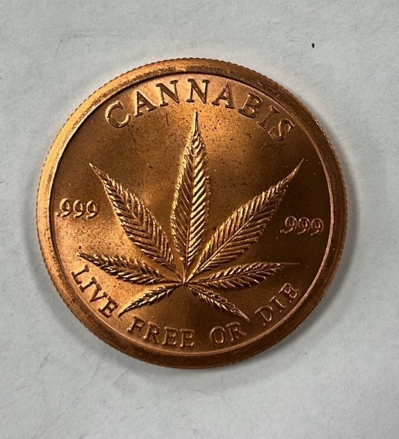
- 45 canisters containing approximately 889 silver coins of varying weight (535.1 oz. silver total)
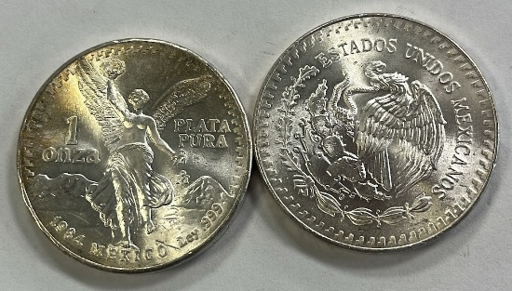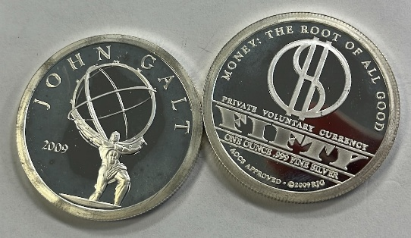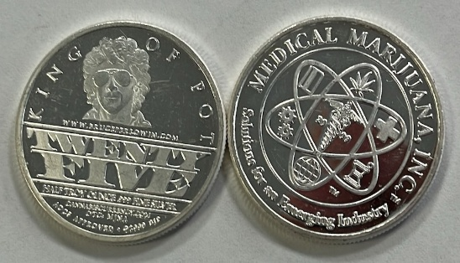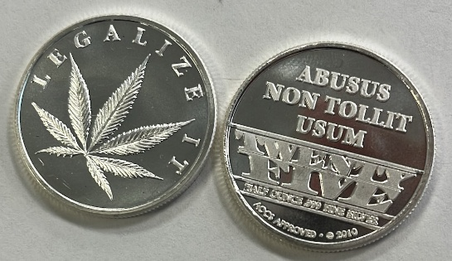
- One sheet of 16 1 oz. copper crackers (16 oz. copper total)
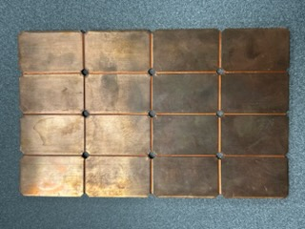
- One pair of earrings, three loose .156 carat diamonds
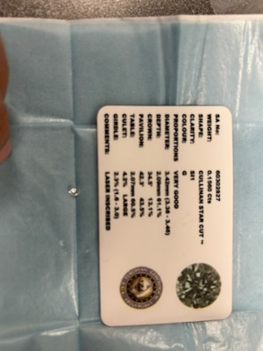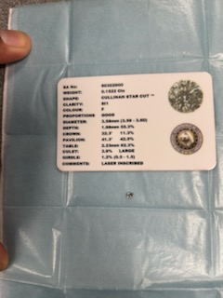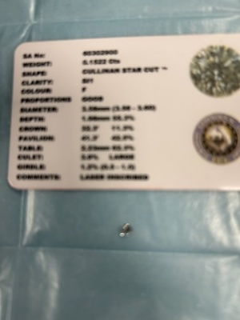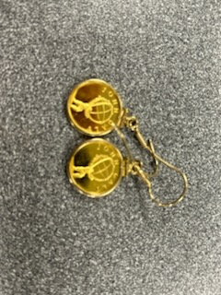
- One pouch containing two pair gold-colored earrings, one gold colored ring, & one gold colored necklace
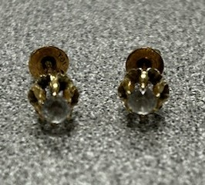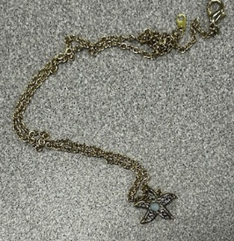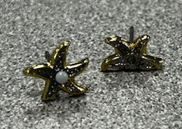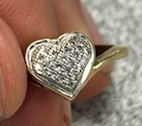
- Four 1 oz. gold coins, 4 1/10 oz. gold coins, & One 1909 20 Franc gold coin (4.5867 oz. gold total)
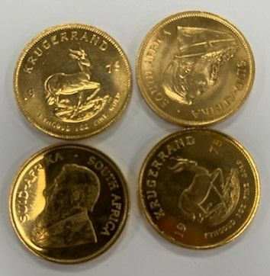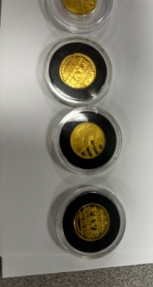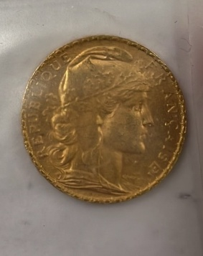
- Five 1 oz. silver coins (5 oz. silver total)
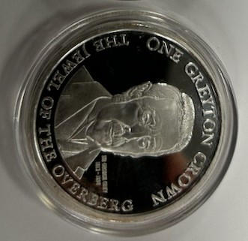
- One Hunkpapa Lakota ½ oz. copper coin, One AOCS approved 1 oz. copper coin, One Rob Gray 1 oz. copper coin, One d’Anconia 1 oz. copper coin, & One Ron Paul 1 oz. copper coin (4.5 oz. copper total)
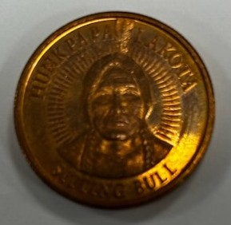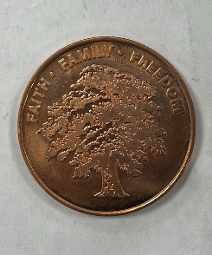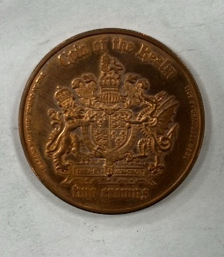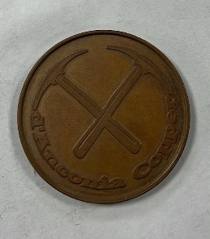
- Four NTR 10 troy oz. silver bar & One Academy 10 troy oz. silver bar (50 oz. silver total)
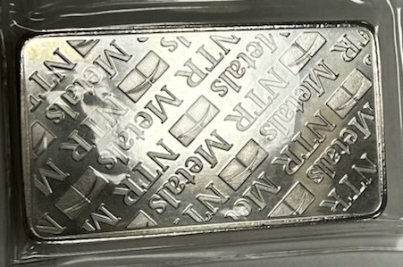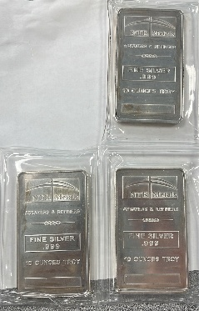
- 23 canisters of 1 oz. copper bitcoin coins (460 oz. copper total)
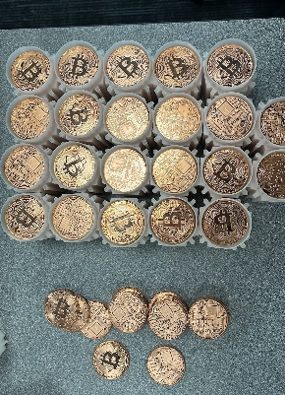
- 25 packages of 1 oz. .999 fine silver Bitcoin coins (approximately 250 oz. silver total)
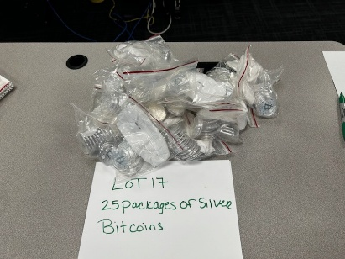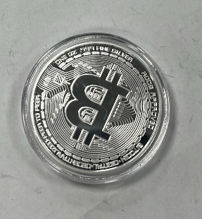
- 20 canisters containing approximately 500 1 oz. .9999 fine silver Canadian Maple Leaf Bullion coins in a plastic case (500 oz. silver total)
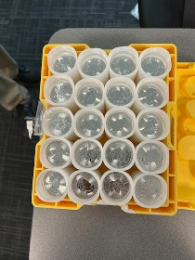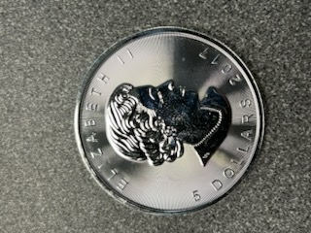
- 20 1/10-gram ValAUrum Liberty Gold Note certificates in a collector case (0.070548 oz. gold total)
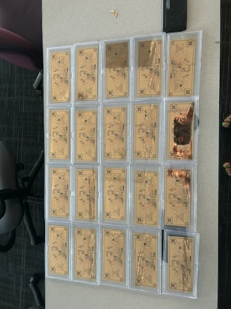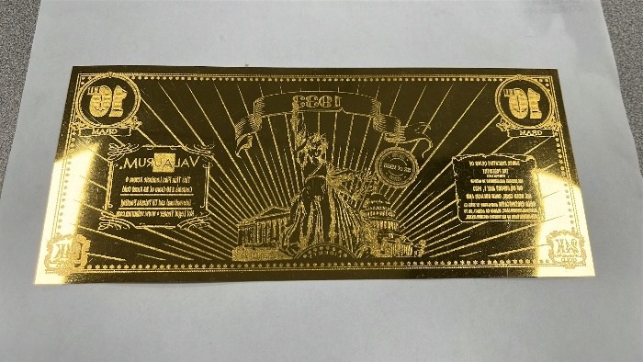
- Approximately 72 silver coins of varying weight (44.4 oz. silver total)
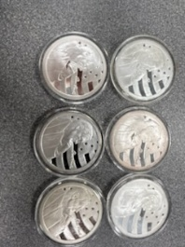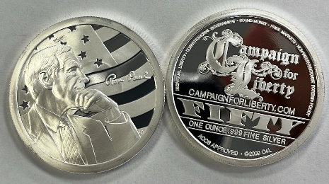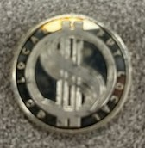
- Approximately 150 pre-1965 dimes & approximately 80 collector quarter dollar coins (25.311 oz. silver total)
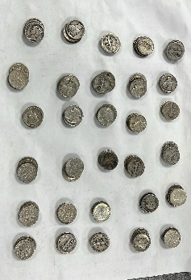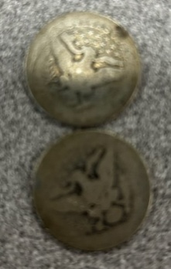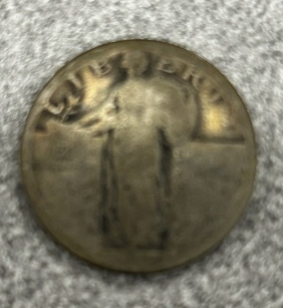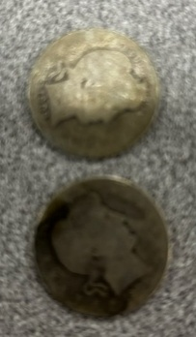
- Approximately 22 gold coins of varying weight (6.1802 oz. gold total)
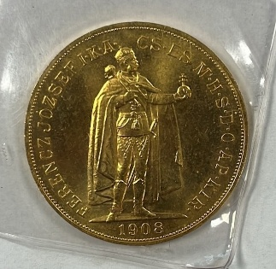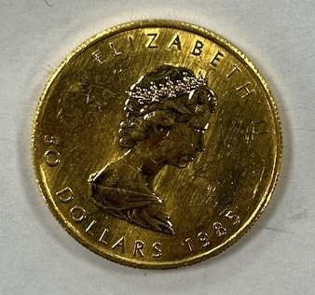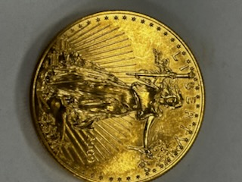
- One 1 oz. NWTM .999 silver bullet (not a real bullet)(1 oz. silver total)
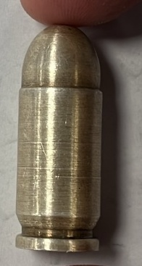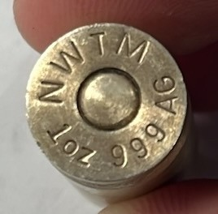
- 20 trillion-dollar silver colored piece (4 oz. .999 fine silver total)
